**CENWP-OD-D 9/5/2024**

**MEMORANDUM FOR THE RECORD**

**SUBJECT: *24TDA08 MFR* *Gatewell Pacific Lamprey Mortality***

September 4 one adult Pacific Lamprey mortality found in gatewell 19-2 during gatewell inspection. Fish was retrieved from gatewell.

1. Species – Pacific lamprey
2. Origin – unknown
3. Length – ~22”
4. Marks and tags – Unable to determine marks due to poor condition. Scanned with no tags detected.
5. Marks and Injuries found on carcass – Unable to determine due to poor condition.
6. Cause and Time of Death – Unknown
7. Future and Preventative Measures – None

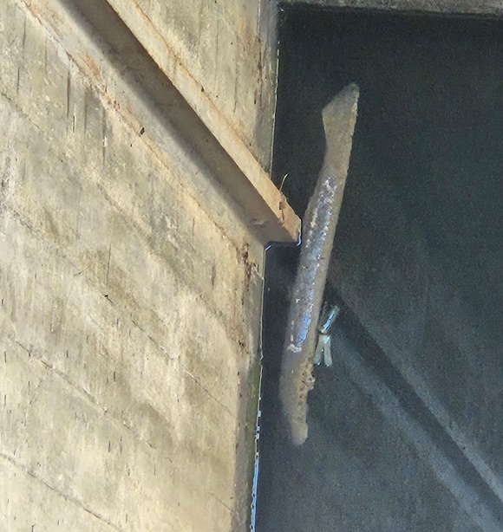

*.*

Sincerely,

TDA Project Fisheries